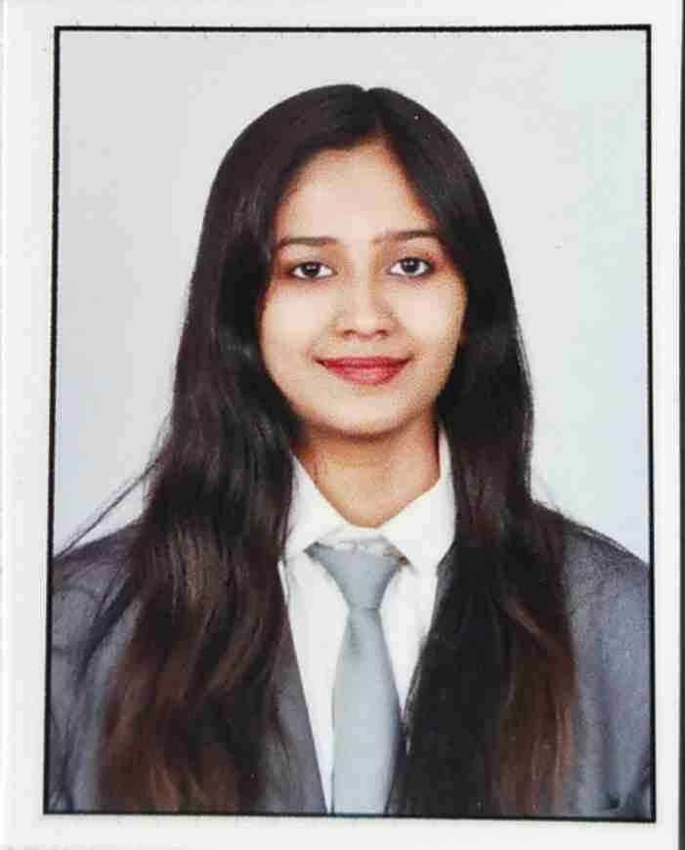

**N.V.S Sushmita**

FINANCE

Your Passport Size Formal Photo

(Remove this text)

Width: 2.7 CM

Height: 3.0 CM

REFERENCES

**__________________________________________________________**

|  |
| --- |
| **Education Summary** |

|  |  |  |  |  |
| --- | --- | --- | --- | --- |
| **Degree|**  **Certificate** | **Stream |**  **Specialization** | **Name of Institution &**  **Board | University** | **YOP** | **Percentage** |
| MBA | Finance | Savitribai Phule Pune University | 2023 | 75.8 |
| B. Com | N/A | St. Thomas College, Bhilai (Durg University) | 2021 | 74.2 |
| Higher Secondary | Commerce | MGM Senior Secondary School, Bhilai (CBSE) | 2018 | 65.4 |
| Senior Secondary | All | MGM Senior Secondary School, Bhilai (CBSE) | 2016 | 81.7 |

|  |
| --- |
| **Internships & Projects** |

**Post-Graduation Internship**

**Organization:** CA Firm (Vinay Kumar Bhattacharya, Bhilai) **Duration:** 2 Months

**Project Title:** A Conceptual Study of Tax Filing Process of salaried individual

**Tasks Undertaken & Learnings:**

* To understand & analyse the Tax Structure
* To help clients in investment to reduce tax liability
* To understand IT Return Filing Process for Indian Residents
* To study capital gains of clients and help clients save taxes

**Graduation Internship**

**Organization:** The Jurni, Bhilai **Duration:** 1 Month

**Project Title:** The Jurni Young Professionals Program

**Tasks Undertaken and Learnings:**

* To bring new subscribers for the magazine
* To pitch and convince people
* Social media marketing

|  |
| --- |
| **Certifications & Training** |

* Tally.ERP9 with GST (210 Hours)
* Financial Markets by Shine Projects (2 weeks)

|  |
| --- |
| **Co-Curricular Activities & Achievements** |

* First prize in group folk dance competition
* Participated in covid vaccination awareness programme

|  |
| --- |
| **Personal Details** |

**Date of Birth :** 09th October 2000

**Languages Known :** English, Hindi, Telugu

**Home Town :** Bhilai, Chhattisgarh

**Email id :** [nvssushmita.riim@gmail.com](mailto:nvssushmita.riim@gmail.com)

**Contact No. :** 7024460291